2022

Email
the.basin.ps@education.vic.gov.au

Website
www.thebasinps.vic.gov.au

Phone
9762 1256
Prep Enrolment and Transition

Message from the Principal

Basin Primary School has been an integral part of the local community for 142 years. Our parents and teachers work together to provide our students with a wonderful environment in which to learn. Our large grounds are the second largest in the state, providing our students with a playground that caters for every child’s needs. Most importantly, our professional and highly trained teachers provide a learning program which aims to develop the social, emotional, physical and intellectual skills each child needs in order to achieve their potential into adulthood. Our school is Child Safe with myself and the Assistant Principals being Child Safe Officers. For further information on child safety, please visit our website: http://thebasinps.vic.edu.au/
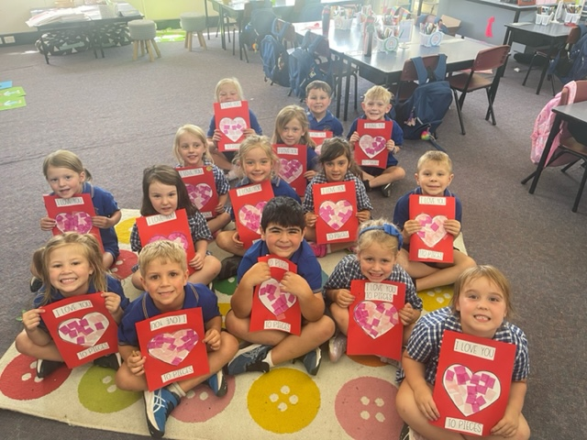
Our school motto is – DREAM, BELIEVE and ACHIEVE.
DREAM - It all starts with a dream. Every one of us dreams, especially when we are young. Are you challenging yourself every day to follow your dreams?
BELIEVE. We need to believe in ourselves to have the confidence, determination, resilience and courage to go after our dreams.
ACHIEVE. Achieving success is a combination of keeping strong, being confident, humble, courageous and never giving up!

In July 2018 a $5.9 million building program was completed at our school. The works included the construction of a large gymnasium which adjoins the existing Performing Arts Centre, a new Administration Building and the upgrade of 12 classrooms. In 2020, $2 million was spent improving our grounds including the installation of a new sensory playground.

Each grade level at The Basin PS have developed engaging units of work based around the Victorian Curriculum, which outlines what is crucial for all students to learn from Prep to Grade 6. As a result our academic results across all areas are high. Schools use the Victorian Curriculum to plan their teaching and learning programs, including assessment and reporting of student progress. The Standards ensure that students continue learning traditional subjects such as English, Mathematics, Science, Humanities, Languages and The Arts. Within these subjects, students learn the physical, personal and social skills they need in life.

Physical, Personal and Social Learning | Students learn about themselves and their place in society. They learn how to stay healthy and active. Students develop skills in building social relationships and working with others. They take responsibility for their learning, and learn about their rights and responsibilities as global citizens. Domains include – Civics & Citizenship, Health & Physical Education, Interpersonal Development and Personal Learning.
Discipline-based Learning | Students learn the knowledge, skills and behaviours in the domains of The Arts, English, Humanities, Mathematics, Science and other languages.
Interdisciplinary Learning | Students explore different ways of thinking, solving problems and communicating. They learn to use a range of technologies to plan, analyse, evaluate and present their work. Students learn about creativity, design principles and processes. Domains include – Design, Creativity & Technology, ICT and Thinking Processes.
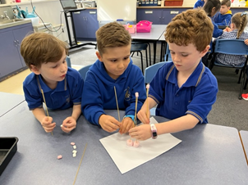
Our wonderful staff includes a mix of age groups and gender. We have seven excellent specialist teachers delivering programs in Performing Arts, Visual Arts, German, Science and Physical Education. Our sporting prowess is second to none. We have achieved a great deal of success in District Athletics, Cross Country and Swimming over a long period of time and won many pennants in a range of team sports. Our dance teams have experienced great success at the state Wakakirri competition and local Dance Fair competition. Dance opportunities are offered to all children from Prep-6.
We actively encourage parents to be part of school programs – which has been a great feature of The Basin PS over many years. We believe that such a partnership improves the learning outcomes of all students. Welcome to our great school. May your time with us be rewarding and provide both you and your child with the best educational experience.

David Orlandi
Principal

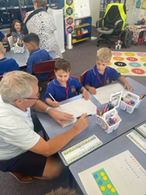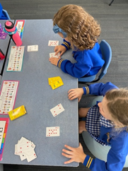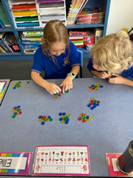

Message from the School Council President

The Basin Primary School would like to welcome you and your family to our School. We work in partnership with the Department of Education and Training (DE&T) and the School Leadership striving to provide an excellent, safe and pleasant environment, both within the grounds and the classrooms to encourage your children to achieve their full educational and social potential.

The School Council is a major decision-making body operating with the Department of Education and Training (DET) guidelines. It is comprised of eight parent representatives, four DET representatives, two co-opted representatives, and the Principal as Executive Officer. Each member is elected for a two year term, with half of the members eligible for re-election each year.

School Council has the responsibility for determining educational policies for the school, overseeing the maintenance of buildings and grounds, financial management, and encouraging community involvement and interest in our school to ensure the children attending The Basin Primary School have the best educational and environment backing we can offer.

The School Council has various sub-committees, each concentrating on a particular area of interest. These sub-committees are comprised of School Council members plus any interested members of the school community.

Our Junior School Council, consisting of representatives from each year level, offers us suggestions from the student’s point of view on ways they feel their school may be improved and enhanced.

All School Council and Sub-committee meetings are open to all members of the school community. Your interest and participation is actively encouraged and appreciated. Dates and times of these meetings will be found in the weekly newsletter.

On behalf of the School Council, I would like to welcome you to our community and wish your child(ren) and yourselves a wonderful experience at The Basin Primary School.

Darrell Holden
School Council President
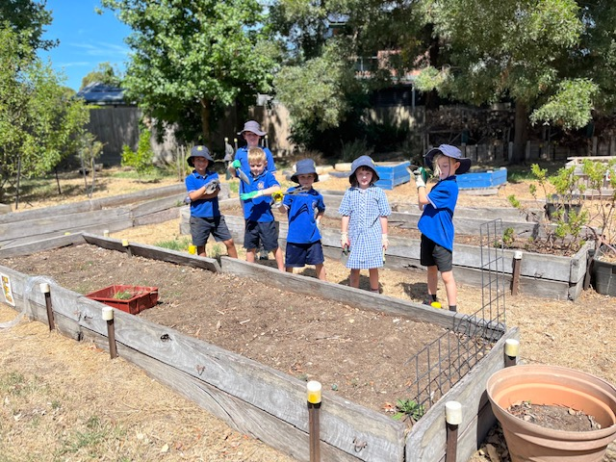
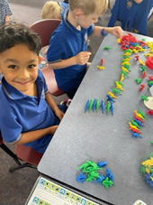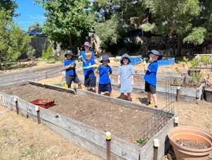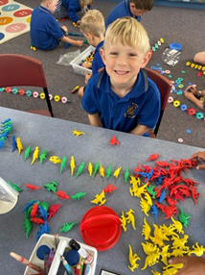

Specialist Curriculum

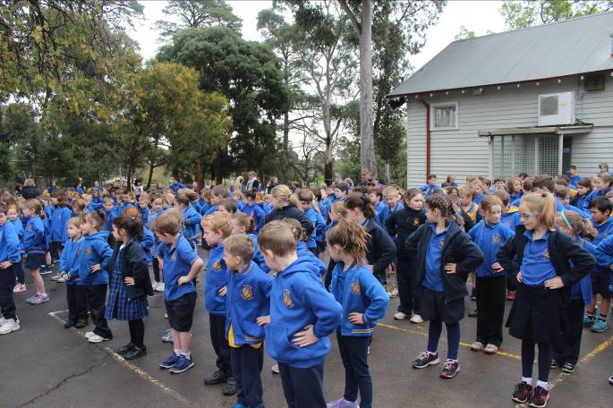
VISUAL ARTS
The Art program covers many aspects of Visual Arts including painting, craft work, pottery, etc.

MUSIC / PERFORMING ARTS
Children will be given opportunities to acquire musical knowledge through a balanced program of musical experiences including singing, listening, playing, moving and creating.

LIBRARY
A library bag is compulsory when borrowing books from the Library. This can be purchased from the Uniform Shop. One book may be borrowed at a time by preps and as children develop greater responsibility they will be allowed to borrow two books at one time. The borrowing period is two weeks. Books may be returned any day, there is a library tub in each classroom for these returns. Borrowing is conducted during library lessons.

PHYSICAL EDUCATION & SPORT
At Physical Education lessons, the children will experience sequential programs in the areas of movement, dance, fitness, swimming, games and skills, and gymnastics. Throughout their primary years the children will also have the opportunity to participate in gymnastics, athletics, inter-school sporting games, cross country, bike education and a host of other exciting sporting events. In both physical education and sport the emphasis in on participation and enjoyment rather than intense competition.

SCIENCE
Since the introduction of science as a specialist subject in 2016, we are delighted with the success of the program and the engagement of our students. We are fortunate at TBPS to have a dedicated science specialist teacher and the students have fortnightly lessons which aim to develop their scientific knowledge and curiosity as well as develop a love for science.

SWIMMING
Swimming is offered to all students during the years Prep through to Year 6. Prep to Year 3 program is conducted at the Knox Pool at the start of December each year. It is an intensive 10 day program with the children being taken to and from the pool each day by bus. Year 4 to Year 6 program is in August. The programs offer the children the opportunity to develop confidence in the water under the guidance of qualified instructors. Parents will be advised of the cost of the program and the provision at Prep level of a Swim and Survive booklet (a record of children’s progress), when organisational arrangements have been made.

GERMAN
German is the language taught at The Basin Primary School with all children from Prep to Year 6 participating. Classes are timetabled weekly with an experienced specialist teacher who speaks German fluently. Our focus in the language program is acquisition of immediately useful oral language alongside being exposed to a broader curriculum. This includes cultural understanding, grammar, songs and games as well as reading and writing in the German language
CAMPS
School camps are held for students in Grades 3, 4, 5, and 6 and are seen as a valuable aspect of a fully rounded program of development for children. The aims in conducting a camp are:
- To provide opportunities for healthy social contact outside the regular school environment for the children and their teachers.
- To develop a sense of independence amongst the children, i.e. in dressing, eating and personal hygiene, etc.
- To provide opportunities for physical development, e.g. hiking, general fitness, outdoor activities.
- To help instil an appreciation of the natural environment of the area being visited.
- To provide educational experiences unavailable at school, e.g. visits to local industries, places of historical interest, etc. These are integrated into the total curriculum.
- Grade 2 children experience a sleepover at school as a lead-in to our camping program.

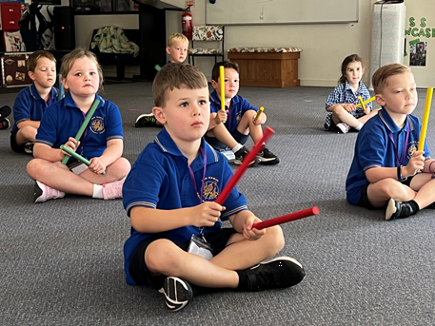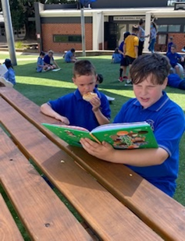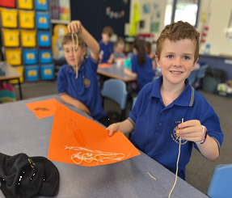

How to enrol your child

- Fill out the Enrolment form available from school.
- Provide us with proof of the child’s age (e.g. Birth Certificate/Extract of Entry) – this can be photocopied at school.
- Bring the child’s Immunisation Certificate which may be obtained from Australian Childhood Immunisation Register (ACIR) by calling them on 1800 653 809.

Enrolment places will be offered to existing families with a prep starting and to families within our zone. We will fill the remaining places from outside the zone in order of receiving enrolment forms. Enrolments will be finalized by August.

The Basin Primary School “Transition from Kinder” program on which will run in Term 4 will provide an opportunity for your child to spend some time in the school setting as well as running information sessions for parents.

We look forward to seeing you at The Basin Primary School.

David Orlandi Dale Goldsmith Donna Krenn
Principal Assistant Principal Assistant Principal

Parental Involvement

PARENT ASSISTANCE WITH CLASS ACTIVITIES
Many parents give up their time to assist with class activities. Involvement in reading programs, swimming and sporting activities, craft programs and excursions all contribute to the overall development of all children. The staff and children value the contribution. Parents will be advised of the areas where the class teacher would appreciate your help. Please note – all parents volunteering in classrooms and excursions, must have a Working with Children Check and provide those details to the office.

WORKING BEES
The Buildings & Grounds Sub-committee organises working bees during the years to enable regular maintenance and upkeep of the school buildings and grounds. Many parents and their children actively participate and have extensively helped improve the school’s facilities. Dates and times will be published in the weekly newsletter. If you are unable to attend on an organised day but would like to offer your services on another date, please contact the Office.

PARENTS & FRIENDS ASSOCIATION (PFA)
Our Parents & Friends Association (PFA) is an active group providing fundraising activities for the whole community, social gatherings and evenings. In Term 1 the PFA help to organise a Prep Family Fun night for Prep parents to get to know each other.

All parents can be part of the PFA, which supports the school through:
- Providing practical ways for parents to get involved in school life
- Gaining insights into school programs and planning
- Sharing and passing on ideas
- Organising community social activities
- Providing services to the children, e.g. Mother’s and Father’s Day Stalls, special hot lunch days, etc.
- Having a co-opted member on School Council
- Providing funds for the benefit of the children.

SCHOOL COUNCIL
School Council meetings are held monthly on the third Monday of the month. The meetings are open and all members of the school community are most welcome and encouraged to attend. The meetings are the avenue by which all members of the school community can meet to hear, discuss and formally act on any issues related to School Council duties and responsibilities. Everyone attending may join in discussions, however, only School Councilors can vote on issues.

Council has the responsibility to determine the educational policy of the school, oversee grounds and buildings, ensure the monies coming into the hands of Council are expended properly, and generally foster the school community’s interest to ensure the children attending The Basin Primary School have access to the highest quality educational programs and a pleasant and safe environment.

2023 Start to School

DATE | SCHOOL TIMES
Monday January 30 | Prep children start at 9:30am and finish at 2.00pm.
All Wednesdays in February | Prep children have individual interviews - 1:1 online Department of Education Numeracy and Literacy assessments.
Thursday February 2 | Prep children’s first full day 9:00am – 3:30pm
March | Prep students full time Monday to Friday

2023 School Term Dates

Term 1 | Monday January 30 to Friday April 7
Term 2 | Tuesday April 24 to Friday June 23
Term 3 | Monday July 10 to Friday September 15
Term 4 | Monday October 2 to Thursday December 21

2022 Term 4 Transition Dates

Session 1 | Tuesday October 11
Session 2 | Tuesday October 25
Session 3 | Tuesday November 8
Session 4 | Tuesday November 22
Session 5 | Tuesday December 6
Parent Information Session | Monday December 5

